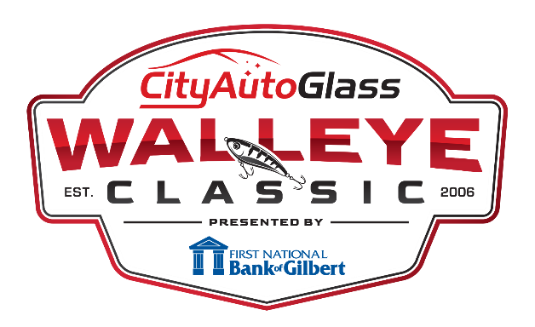

PLEASE PRINT
2022 OFFICIAL ENTRY FORM
$500.00 Entry Fee

Partner #1 Address City State Zip Phone ( ) -
E-mail __________________________________________________________
BOAT INFO:
Boat brand Length Model year Outboard brand Horsepower
IT IS REQUIRED THAT ALL BOATS HAVE A LIVEWELL WITH A RECIRCULATING OPTION.
Partner #2 Address City State Zip Phone ( ) -
E-mail________________________________________________________

REGISTRATION FEE IS NON-REFUNDABLE

- LIABILITY RELEASE AND HOLD HARMLESS AND INDEMNIFICATION AGREEMENT. I hereby release the City Auto Glass Walleye Classic which is organized and operated by The CAG Foundation, its officers, directors, agents, volunteers or employees, sponsors and Jamie Lindseth from all negligence, damages, claims, demands, costs or fees relating to injury to any person or property which I or any passenger may sustain and which is caused by any negligence, foreseen or unforeseen and which may be attributed to City Auto Glass Walleye Classic et al’s negligence, acts or omissions, and which is related to my participation in this activity. Further I hold harmless and indemnify City Auto Glass Walleye Classic. et al, for any acts which may be attributable in part or in whole to my actions or negligence and where any other person or passenger suffers any type of damage whatsoever. I agree to hold harmless City Auto Glass Walleye Classic et al, for any attorney’s fees they incur in defense of my acts and omissions and negligence. I understand that by participating in this tournament that I may cause or sustain injury including but not limited to: loss of life, loss of limbs, electrocution, paralysis, coma, loss of mental functions, loss of sight, loss of speech/smell, dehydration, exposure, hypothermia, frostbite, sun stroke and all other injuries that may be caused in a boating accident and/or exposure to the elements. I further release and indemnify City Auto Glass Walleye Classic, et al for all damages relating to adverse weather conditions while participating in this Tournament. It is my responsibility to seek safety should adverse and/or unforeseen weather conditions occur prior to, during or after the tournament. I agree that any litigation between myself and City Auto Glass Walleye Classic et al will be heard in the MN Dist. Ct. for St. Louis County, MN applying MN laws.
- COVENANT NOT TO SUE & WAIVER OF SUBROGATION. I agree that I will not sue City Auto Glass Walleye Classic, et al for damages on account of any negligence causing injury, death or damage I suffer or cause whether known now or which may develop in the future. In the event a claim is made against City Auto Glass Walleye Tournament et al on account of my negligence, actions or omissions, I expressly agree to indemnify and hold City Auto Glass Walleye Classic
et al harmless from any liability whatsoever, including court costs and attorney’s fee, arising with respect to such actions. I understand that in waiving my rights to sue City Auto Glass Walleye Classic, et al I am also waiving the rights of recovery from City Auto Glass Walleye Classic, et al of my insurance carrier for
any claims they may pay on my behalf.
- VERIFICATION OF LIABILITY INSURANCE. I maintain a minimum of $100,000 liability insurance on the boat I will use in this activity. Insurance policy must state that the insurance covers the boat and any liability of the owner or operator.
- POLYGRAPH/VOICE STRESS TEST Failure to take or pass the polygraph/voice stress examination when asked to will result in disqualification without recourse.
- PUBLICITY. In consideration for permission to participate in the City Auto Glass Walleye Classic, I hereby grant to The CAG Foundation and its assignees the unconditional right to use my name, voice, photographic likeness, and biographical information in any medium whatsoever, including but not limited to video/audio productions, merchandising, promotions, articles, and press releases. I understand that I will not be entitled to receive any royalties and other compensation in connection with such use and waive my right to review the finished product.
- I SIGNIFY by my signature that I have read all Tournament rules and this liability release and agree to abide by all rules, regulations, releases and tournament official’s decisions. I agree that this release is binding for all City Auto Glass Walleye Classic events in which I may participate including the championship invitational.

Signature Date

Signature Date
PLEASE MAKE CHECKS PAYABLE TO “THE CAG FOUNDATION”
c/o City Auto Glass, 710 West 41st Street, Suite 2, Hibbing, MN 55746 • (218) 780-0901
Or register online at www.cityautoglasswalleyeclassic.com

